Exp no 18

AIM: Design TM using simulator to accept the input string ww

INPUT:

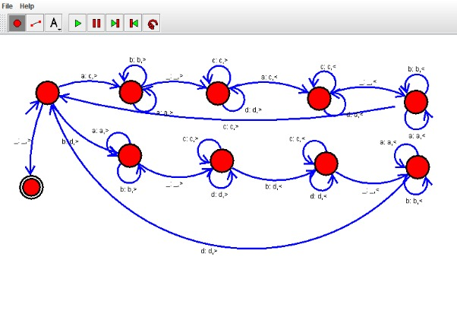

RESULT:

Hence, We designed a TM using simulator to accept the input string ww